

EDITORIAL

Since December we have had some great activities for everyone to enjoy. This is possible because you, as the members, have been so good and provided us with your preferences.

We have had many theme days including Chinese New Year, outings to local attractions visiting the Ansett and Pastoral Museums, Valentines, Easter and Mother’s Day. You have all contributed to a wonderful, full program and it has been dotted with guest speakers, music, outings to Dartmoor, Cavendish, a tour of the Hamilton streets and Hamilton community outings. We recently had a three day trip to Daylesford. Lots of positive comments were made about the quality of the trip. Video and photos are yet to come.

**

*Michelle*

Dorothy Stevenson

WE HOPE YOU ALL ENJOY YOUR TIME WITH THE PLANNED ACTIVITY CHARM GROUPS

Morna Gummow

Mary McDonald

Carmel Harrison

Mick Forrest

David Black

Viv Byron

Keith Gee

Joyce Riley

Betty Steer

Helena Vandooren

Thelma Williams



 *We extend our deepest sympathy to*

*families and friends of*

*June Walter, Carmel Scott, Bob Steer,*

*Les Paton and Nora Walker.*

*Our lives have been greatly enriched through the many special times we shared together at PAG Charm Group. Your memory is our treasure.*

**PLANNED ACTIVITY CHARM GROUPS**

**ATTENDANCE AND CANCELLATION**

Unless we are notified, staff will expect you are attending on your planned days. If you are unable to attend, please note it is very important to **phone before 9.00am on the day** – **otherwise your meal will be ordered and you will be charged for it.** This is also important for pick up lists and other planning for the day which all commences before 9.00 am.

**The numbers to ring are:**

**HAMILTON GROUPS: 555 18 381 or 0438 003 514**

**PENSHURST GROUP:**

**0417 017 728**

**Thank you for your assistance.**



**Happy Birthday**

C:\Documents and Settings\Laurise.Owen\Local Settings\Temporary Internet Files\Content.IE5\0HQHO5IR\MC900022528[1].wmfC:\Documents and Settings\Laurise.Owen\Local Settings\Temporary Internet Files\Content.IE5\0HQHO5IR\MC900022528[1].wmf

“SPECIAL BIRTHDAYS”

7th June Mary McDonald 80

10th August Margory Meyer 90

15th August Liz Chapman 65

BIRTHSTONE BIRTHFLOWER



JUNE Rose

2nd Kath Dunbar

7th Helen Gerik

14th Henny Pember

15th Jean Fyfe

30th Dini Vandermost



JULY Waterlily

6th Kevin Thomas

9th Dorothy Stevenson

12th Mary Kearney

14th Rae Blaby

15th Jean Kennett

22nd Joyce Brooker

22nd Dulcie Black

28th Gwen Tonissen

AUGUST Gladiolus

2nd David Chace

6th Joan King

7th Lillian Anson

7th Carmel Harrison

11th Patty Preece

12th Ben Kennett

22nd Roslyn Rideout

24th Leo Ryan

*We wish you all a very Happy Birthday and*

*may your next year be full of good health and happiness.*

News from Brenda:

Hello everyone, what a full year of activities we are having. We know you are all enjoying the benefits of new programs, opportunities and new friendships.

We have new equipment arriving to enhance the PAG Charm group. Our new fridge arrived last week and looks fabulous beside the matching freezer. Please ask staff where these are and arrange to have a look at them. As they are WILLIAMS brand thoughts are being floated with suitable names: Willy 3 and Willy 4 (we already have Willy 1 & 2 in our Friday group) or Bill and Will. Staff will find out your preferences to name the freezer and fridge soon.

We have 16 new chairs on order; these should be arriving very soon. The chairs will replace some of the existing lounge chairs in Allied health building. Members are being offered the opportunity to purchase a chair for $30 each. Let Brenda or Kate know if you would like one.

A Kenwood Mixmaster is on order; we look forward to christening this shortly with preparing lots of yummy foods to enjoy at Charm group.

15 LAPTOP COMPUTERS

We have received a donation of 15 laptops from SGAE, Hamilton. This wonderful donation is enabling staff to plan for computer/IT sessions with all interested members. As soon as the network is set up and running, this opportunity will be offered to you. *Stay tuned.*

SATURDAY GROUP

The regular Saturday group will cease in its current form on Saturday June 21st. Members have been offered a day of their choice during the week, and for the last few months have been participating in week day groups. Charm group will offer a weekend group occasionally to ALL MEMBERS for special events in the Community as they come along.

Tammy, our food services extraordinaire, has commenced working in Dietetics for 6 months to help out during a maternity leave vacancy. We are currently advertising to fill this temporary position at PAGS. Stay tuned. Keep smiling and keep warm, *cheers Brenda*

COMING EVENT

Regional Planned Activity groups will be

joining together to hold a

WINTER WARM UP DANCING DAY on

Tuesday June 17th at the Senior Citizens

building in Hamilton. *More details soon*

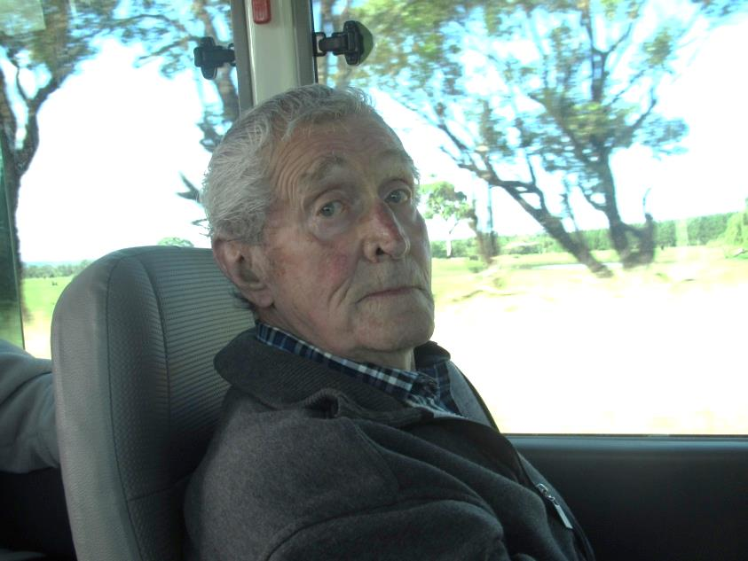

NAME: John Langford

DATE OF BIRTH: 9th October 1934

PLACE OF BIRTH: Dandenong

TOWNS WHERE I HAVE LIVED: Frankston, Wangaratta and Hamilton

OCCUPATION: Soil Conservationist

SPECIAL ACHIEVEMENTS: Diploma of Agriculture

CLUBS/GROUPS I HAVE BELONGED TO: Apex – Life Member

OTHER HOBBIES & INTERESTS: Apex, gardening and reading

I ADMIRE: Nelson Mandela – his principles

I DISLIKE: Where the youth of today are heading and obesity

FAVOURITE TV PROGRAMS: ABC television – documentaries and current affairs

FAVOURITE FOODS: Fish

WHAT I WOULD DO IF I WON TATTSLOTTO: Set the family up and give the rest to favourite charities

MY ADVICE TO THE YOUTH OF TODAY: To grow up and use their manners

TAMMY’S RECIPES HINTS AND IDEAS

MOCK CHICKEN SANDWICH FILLING

* Make twice the quantity and freeze some for later in one-serve containers.
* Homemade soups or stews are a great way to use leftovers - cook extra and freeze it in one-serve containers.
* Use a microwave or a pot with a steamer to cook vegetables – it saves time, power and money.
* Make an omlette or scrambled eggs with grated or diced vegtables, such as carrot, zucchini, tomato, corn or mushrooms. Serve with potato, peas and/or pumpkin.
* Have tinned fish (sardines, tuna or salmon) on toast with mixed vegetables.
* Heat tinned fish with cooked pasta or rice and vegetables (such as corn, peas diced carrot or zucchini).
* Frozen or canned vegetables and fruit are nutritious and economical.
* Mix and lightly fry diced ham or bacon, frozen or fresh vegetables and cooked rice.
* Cook a jacket potato in the microwave, top it with baked beans and serve with a salad.

1 onion, finely chopped

1 tablespoon oil

2 tablespoons water

1 firm tomato, finely chopped

1-2 tablespoons chopped, mixed fresh herbs

1egg, beaten with a fork

Salt

Put onion, oil and water in a small

non-stick pan. Cook with lid on until

onion is wilted and water absorbed,

then cook uncovered, without

browning for 2 minutes longer. Stir in

tomato and herbs, cook for 2 minutes

longer. Add egg and cook gently as for

scrambled egg, just until egg is set.

Season to taste. Refrigerate up to 2 days.

SAUSAGEMEAT SQUARE

This square contains fruit and vegetables –

it’s a good way to hide them.

450-500g sausagemeat

1 large egg

1 teaspoon curry powder (optional)

2 tablespoons tomato sauce (or plum sauce)

C:\Users\Paula Heine\AppData\Local\Microsoft\Windows\Temporary Internet Files\Content.IE5\CS9YT0FI\MC900413024[1].wmf1 large onion

1 medium apple

1 medium potato

1 large carrot

½ cup grated cheese

Heat oven to 170˚C. Mix sausagemeat, egg,

curry powder and sauce in a large bowl.

Grate the onion, unpeeled apple and the

scrubbed, unpeeled potato and carrot,

then mix them evenly through the meat

mixture.Press mixture into a 23cm square

baking pan lined with baking paper. Sprinkle

with the cheese and bake for 45 minutes,

until firm in the centre. Cut into 9-12 pieces.

Refrigerate or freeze for lunches.

JOKE TIME FROM JACQUI –

WITH SOME HELP FROM DAUGHTER ZOE

They are

always butting in.

Cough stirrup.

Why is it hard to have a conversation with a goat?

What do you give a pony with a cold?

A groundhog.

It kept running out of the pen.

What do you call a pig with no legs?

Why did the farmer call his pig ‘Ink’?

He was feline funny.

Why did the cat go to the doctor?

They had a white webbing.

Did you hear about the spiders who got married?

A catastrophe.

What do you call an accident prone cat?

A lot of very nervous cats.

What do you get if you cross a canary with a Rottweiler?

A homeless snail.

What’s the definition of a slug?

Swine Lake.

What do you call a ballet about pigs?

How do you describe an annoyed pig?

Disgruntled.

Sleep somewhere else.

What would you do if you found a crocodile in your bed?

About a mile a day.

What was the snail doing on the road?

An Ali-grater.

What do crocodiles use to grate cheese?

C:\Users\Paula Heine\AppData\Local\Microsoft\Windows\Temporary Internet Files\Content.IE5\CS9YT0FI\MC900423169[1].wmf

Hope you got a few smiles from these quirky jokes

*PAG (CHARM) RAFFLE WINNERS*

*Easter Raffle Major Prizes*

1st Di Jacobson

C:\Users\Paula Heine\AppData\Local\Microsoft\Windows\Temporary Internet Files\Content.IE5\EVIAH7UA\MC900254392[1].wmf2nd Kerryn Feeley

3rd Lorraine Northcott

*Easter Raffle Daily Winners*

Monday Joan Ruthven

Tuesday Stuart Ridley

Wednesday Wendy Allen

Thursday Hamilton Joan Blain

Thursday Penshurst John Cumming

Friday Jean Kennett

*Mother’s Day Raffle*

1st Jack Gower (watch)

2nd Nancy Evans (ladies package)

3rd Mick Forrest (Grampians Photo)

**PAG FEE SCHEDULE 2014 – 2015 effective from 1/6/2014**

|  |  |  |
| --- | --- | --- |
| **CONCESSION** | **$ 10.50** | Pay on the day charge, includes meal at PAG |
| **ACTIVITY ONLY** | **$ 7.40** | No meal supplied, activity only |

Arm chairs for sale

Adjustable height

 Head rest

Colours: Light grey or pink

**$30 each**

**See Brenda or Kate**

[](https://www.google.com.au/url?q=https://www.poconohealthsystem.org/?id=228&sid=1&sa=U&ei=geCDU8SOL8qMkwXok4D4BA&ved=0CFAQ9QEwEQ&usg=AFQjCNFVRhIIbQ82s0kuz1iNkO-G8riFDw)

**PLANNED ACTIVITY**

**CHARM GROUP**

**Thankyou to all our wonderful volunteers**

During May the nation celebrated national Volunteers week. Our PAG volunteers bring a radiant spark of friendship to us all, and we all join in thanking you for your time, assistance, patience, support and never ending willing hearts to assist us at PAG ‘Charm’ group.

Volunteers are the only human beings on the face of the earth who reflect this nation's compassion, unselfish caring, patience, and just plain loving one another.

~Erma Bombeck

**8 Ways to Beat the Winter Blues**

**Keep Your Energy High and Mood Lifted**

C:\Users\Paula Heine\AppData\Local\Microsoft\Windows\Temporary Internet Files\Content.IE5\DU1521R3\MC900432455[1].wmfC:\Users\Paula Heine\AppData\Local\Microsoft\Windows\Temporary Internet Files\Content.IE5\CS9YT0FI\MC900432485[1].wmfAs the days get shorter and the nights get colder, even the best of us can get a little down. The "winter blues" are characterized by mild depression, lack of motivation, and low energy. There’s a lot you can do to prevent the blues from coming on and get yourself back to normal.  
**1. Exercise**  
Exercise is great for relieving the stresses of life. The effects can last for several hours. You’ll have more energy throughout the day. Exercise helps your mind by

releasing those "feel good chemicals" that improve your mood.   
**2. Eat a Healthy Diet**  
What you eat has a great effect on your mood and energy. Avoid refined and processed foods like white breads, rice, and sugar. These foods zap your energy levels and can affect your mood. Eat more complex carbohydrates such as whole wheat breads, brown rice, veggies and fruit. These healthy foods provide your body and mind with nutrients,

C:\Users\Paula Heine\AppData\Local\Microsoft\Windows\Temporary Internet Files\Content.IE5\CS9YT0FI\MC900434387[1].wmfand stabilize your blood sugar and your energy levels.   
**3. Get Some Sun**  
Most people know that sunlight provides us with Vitamin D. But did you know that it also improves your mood? Lack of sunlight can cause many people to become depressed. Sunlight exposure releases neurotransmitters in the brain that affect mood. Try to spend a little more time outdoors.  Keep your shades up during the day to let more light in and sit near windows.

**4. Act on your Resolutions**  
A study showed a strong link between healthy behaviours and depression.

People who exhibited healthy behaviours (like exercising, not smoking, etc.) had

C:\Users\Paula Heine\AppData\Local\Microsoft\Windows\Temporary Internet Files\Content.IE5\EVIAH7UA\MC900434375[1].wmfless sad and depressed days than those whose behaviours were less than healthy.  
**5. Avoid Excessive Alcohol**  
Staying in with a [cold](http://www.sparkpeople.com/resource/wellness_articles.asp?id=341&page=2) beer or a nice glass of wine may seem like the only thing to do in the winter months. But alcohol is actually a depressant, and rather than improving your mood, it only makes it worse. Moderate drinking is fine for most people, but binge drinking (defined as having 5 or more drinks in one sitting) is never a healthy choice.

C:\Users\Paula Heine\AppData\Local\Microsoft\Windows\Temporary Internet Files\Content.IE5\46I83CRK\MC900432477[1].wmf**6. Treat Yourself**  
Having something to look forward to can keep you motivated. If you plan something exciting, your mood improves while you’re anticipating it and when the event comes. Plan something that’s exciting to you—a weekend trip, a swim at the pool, a card game, or special event like a play, night out or sporting event.

C:\Users\Paula Heine\AppData\Local\Microsoft\Windows\Temporary Internet Files\Content.IE5\46I83CRK\MC900434383[1].wmf**7. Get Social Support**  
Don’t underestimate the power of friends, family, and neighbours. Who can you turn to when you’re down and need a pick-me-up? Don’t be afraid to ask for help or encouragement when you need it.

C:\Users\Paula Heine\AppData\Local\Microsoft\Windows\Temporary Internet Files\Content.IE5\DU1521R3\MC900434405[1].wmf**8. Catch some Zzzz’s**  
People naturally want to sleep a little bit more during the winter. Aim for 7-8 hours each night, and try to keep your bedtime and waking time consistent. That way, your sleeping patterns can normalize and you’ll have more energy. Don’t forget naps!

A short (10-30 minute) afternoon nap may be all you need

to re-energize for the rest of the day.

