SOCIAL SUPPORT GROUP - “CHARM”

(Caring, Healthy, Adult Recreation and Music)
NEWSLETTER- SPRING 2018
The focus of your Social Support Group is
- To support you to live well
- To enable you to achieve and feel valued
- Helping you build on what you can do
Through
- Active Service Model
- Person Centered Care
- Goal Setting
- Exercise program
- Support and Respite.
Held at:-
WDHS
Allied Health Centre
and
Penshurst Sheppard Community Centre
COMING EVENTS
- Footy Week
- Outings to various locations
- Seniors Week Activities
- Halloween
- New food delicacy’s
- Music practise

Phone Numbers
Hamilton - 555 18 381
Or 0438 003 514
Penshurst - 0417 017 728

SSG editorial
Welcome to another addition of the Social Support Group newsletter.
Well it has been a very wet and cold winter once again this year, however that has not stopped all the fun activities happening here at Social Support Group.
Every chance we have had for a ½ or full group outing we take it exploring all over the community and surrounding places like Ararat, Casterton, Warrnambool even Port Fairy.
We have also got a few new interest groups that have been running now for a few months more and more members are getting involved with these groups. If you would like to know more about those fancy device’s they call Tablets or IPAD’s we have a group running the third Friday of each month in the morning with Belinda. If craft is more up your ally we have a great Craftanoons group that is expanding so well it is looking like it will become a full day activity so you can get more crafty projects done. Love being outside in the garden or even just getting out and about to look at garden related things well Monday’s Garden lovers group is just for you.
Well that’s a rap look forward to seeing what Spring will bring.
Cheers
Amy

We would like to say a big welcome to Gill Cutchie, Keith & Bev Dunn, Ada Robinson, Doug Prest, Roy Lumb, Bert Diamond, Kate Kuiper, Bruce Cuming, Colin Warfe, Joanne Heffernan, Anthony Milledge, Reg Anderson and look forward to you being part of our group for a long time
Farewell
We farewell Gwenda Harding, Joyce Laidlaw Dawn Schwarz, Allan Klobe and wish you all well in your new homes. We wish and Myra Pohl all the best in all her interests in the Community.

SYMPATHY
It is with great sadness we say farewell to Mary Kearney, Norma De Witte, Mavis Gilding, Kevin Thomas, and Jack Foran who have passed away. We extend our deepest sympathy to their families.
SOCIAL SUPPORT GROUP SENIORS FESTIVAL - OCTOBER 2018
This year our event will be a morning of music & dancing at Seniors Citizens Club rooms, commencing at 10am with Devonshire tea on FRIDAY 26TH OCTOBER Musicians will be provided by our very loved musicians Eric Ryan and John Donkers.
COST: GOLD COIN DONATION

“HAPPY BIRTHDAY WISHES”

We wish you all a very happy birthday and may your next year be full of good health and happiness

September Birthstone Birth flower
Marion Pitts 5th sapphire morning glory / aster
Yvonne Cogger 10th
Beryl Stephens 14th
Brian Shaw 20th
Rosemary Trimnell 20th
October
Ruth Linke 4th Opal or tourmaline Calendula/Marigold
Alison Lyons 8th
Pat Bell 8th
Lorraine Mirtschin 8th
Judy Millard 9th
Phyllis Isbell 10th
Paul Jones 20th
Beth Staude 23rd
Muriel Bailey 24th
Val Groves 28th
November
Ted Barker 10th Topaz or Citrine Chrysanthemum
Janet Gilles 11th
Stuart Ridley 11th
Roy Lumb 11th
Brenda Hartwich 16th
Debbie Dyson 17th
Allan Klobe 19th
Janice Mitchell 24th
Helen Jellie 29th
Special Birthday’s
Yvonne Cogger – 85 Rosalie Lamond – 40
Ruth Linke – 75 Lindsay Norris - 70
Judy Millard – 85 Debbie Dyson - 55
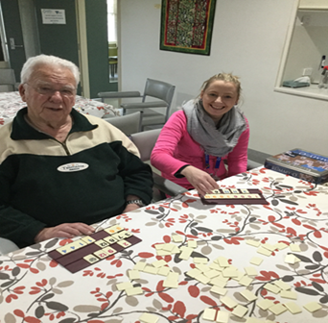
FIVE MINUTES
WITH: PHIL REID

Towns you have lived: Nyah, Bendigo, Quambatook, Ouyen, Sunbury, Kyneton, Trentham, Dunkeld, Hamilton.

Occupations: Primary School teacher and Principal.

Clubs I belonged to: Rotary, Lions and Church.

Hobbies/Interests: Computer, Reading, Football (especially Collingwood).

TV Shows you like to watch: Judge John Deed, Inspector Morse and Inspector George Gently.

Favourite Food: EVERYTHING!!!

What would you do if you won Tattslotto: Give most of it to his children and the Rotary Foundation.

What is your best advice for the youth of today: Get a good education.

What is your favourite activity when you attend Social
Support Group?? I enjoy all the activities provided and really look forward to attending each day.

QUIZ TIME
INVENTIONS
1. Who invented the telephone?
2. What did John Logie Baird invent?
3. What function did a polygraph have?
4. Who was widely praised for his pocket calculator but ridiculed for inventing the C5 electric car?
5. By what name was the John Gabel Entertainer to become better known?
6. What was the purpose of the Archimedes Screw?
7. Who invented the first mechanical calculating machine?
8. Who invented the sandwich?
9. Which people invented the first real paper?
10. What invention revolutionized horse riding?
11. Which human invention was the first object to travel faster than the speed of sound?
12. What was Sheffield Silver?
13. Who invented the saxophone?
14. What contribution did William Fox Talbot make to photography?
15. Who invented an electrical telegraph that transmitted messages in a code of dots and dashes?
16. What was the first stapling machine used for?
17. The Romans invented the hippo sandal. What did it do?
18. How did the military tank get its name?
19. In 1921 it was discovered that insulin, a hormone extracted from the pancreas of pigs, could be used to treat which disease?
20. What was the first product to be made of nylon?

TOPICAL INFO FOR SPRING
Dealing with Allergies.
In spring, allergies affect many people, regardless of age. But seniors’ immune systems can weaken with age, lowering their ability to fight off infections, and their thinning skin can make older adults more prone to contact dermatitis.
Allergic rhinitis affects 12% percent of older adults, according to a 2017 paper. Symptoms are similar to the common cold: nasal congestion, sneezing and itching.
Some allergies result in allergic conditions of the skin, the most common of which is pruritus (itching). Pruritus can indicate lots of other health issues for seniors – such as blood, kidney, or liver diseases; drug reactions; or neurological and psychological responses – so sometimes it’s hard to pin down an allergy. Both topical and internal medications are used to treat skin allergies.
• Staying indoors on especially windy and high pollen count days will help.
• Wearing protective clothing while in the garden to avoid contact with allergens i.e. plants/grasses etc.
• Always having a good supply of anti-histamine medication ready and taking it early on so an allergic attack does not get too severe.
• Using a nasal cleanse with saline solution while not very comfortable will reduce the amount of pollen in your nasal passages and help with stuffiness.
Adjusting to Daylight Savings Time
Adjusting to Daylight Savings Time (DST) can feel similar to having jet lag because it plays with our natural circadian rhythms. During the transition period, seniors may experience difficulty getting to sleep, or disruptions during it. This is problematic because sleep is an essential component of overall health, and sleep deprivation can lead to a variety of issues, like:
• Daytime fatigue
• Concentration loss
• Nausea
• Appetite changes
• Stomach upset
• Mood disturbances
More serious health problems can result from loss of sleep, too. A 2015 study found significantly increased risks of acute myocardial infarction in men taking ACE inhibitors in the first 3 days after the change to DST.
Additionally, seasonal changes may prompt seniors to divert from their prescribed medication schedules, resulting in potentially dangerous over- or under-medication.
All of these geriatric health problems increase seniors’ risk of falling.
Seniors and their caregivers can use good sleep hygiene techniques, such as:
• Blocking out sound and/or light (as long as this doesn’t compromise safety)
• Practicing relaxation techniques before bedtime
• Avoiding television, screen time, alcohol, caffeine and food several hours before bedtime
• Using the bed for sleep only
• Staying on or re-establishing a bedtime routine
A good plan is to not schedule any strenuous activities for the first week or so of Daylight Savings, that way you are not over taxing yourself when you are feeling less than your best.
* * * * * * * * * * * * * * * * * * * * * * * * * * * * * * * * * * * * * * *
QUIZ ANSWERS
- Alexander Graham Bell 2. Television 3. It was an early lie detector
4. Sir Clive Sinclair 5. The jukebox 6. To raise water
7. Charles Babbage 8. The Earl of Sandwich 9. The Chinese
10. The saddle 11. The whip 12. Copper plated with a thin layer of real silver
13. Antoine Sax 14. He invented the photographic negative 15. Samuel Morse
16. Fixing the soles to the uppers of shoes 17. It was a primitive horseshoe tied on with leather thongs
18. For security reasons it was pretended that they were water storage tanks
19. Diabetes 20. Toothbrush bristles
FUND RAISING:
Congratulations and thank you to everyone for your wonderful response to our Biggest Morning Tea fundraiser. $448.00 was raised Well done.
July Vegie Raffle: $102.75 Congratulations Trevor Dunn.

Tuesday Trading Table: Blaze Aid Fundraiser $47.40
Fathers Day Raffle: Raised $464.00
1st – Joy Ahearn, 2nd – Doug Prest, 3rd – Katie Kuiper, 4th Val Groves
A BIG THANKYOU Chelle and Belle and Lorraine for selling tickets.
Members Rights when attending Social Support Group
Where can I go if I have a concern?
Anyone can raise a concern. We encourage you to raise your concern with the service provider first. This can achieve a fast and sustainable resolution. This includes people receiving care, partners, family, representatives, friends, advocates, staff and volunteers.
If you are raising a concern about the care someone else is receiving, you should make sure the person (or his or her representative knows about it)
If you cannot resolve your concern with the service provider, you can contact the Aged Care Complaints Commissioner on 1800 550 552.
Advocacy:
An Advocate is someone who can act on your behalf should you require assistance with issues relating to the health service provider or accessing the health service. Some of the common uses of advocacy services include:
- Access to disability services
- Guardianship issues
- Dispute resolution
- Legal problems
- Making a complaint
Contact Southwest Advocacy Association Inc. on 03 55614584
RECIPE CORNER
Potato Gnocchi
1 1/2 pounds potatoes
2 egg yolks
1/2 teaspoon salt
1/8 teaspoon ground black pepper or ground
white pepper
3/4 - 1 cup all-purpose flour
1/4 cup butter
2 tablespoons snipped fresh parsley
1/2 cup finely shredded Parmesan cheese (2 ounces)
Lemon wedges
Directions
1. Cook potatoes until just under firm.
2. Push potatoes through sieve or potato ricer.
3. In a small bowl whisk together egg yolks, salt, and pepper. Make a well in the centre of the potatoes; add egg mixture to the well. Stir to combine. Add 3/4 cup of the flour, stirring just until combined. Turn out onto a lightly floured surface. Knead in just enough of the remaining flour (may not need any) to make a smooth, fairly soft dough that is still slightly sticky. Do not over-knead or add too much flour or the gnocchi will be heavy.
4. Divide dough into four portions. Roll each portion into a long, thin log, 3/4- to 1-inch thick. Cut logs into 1/2-inch pieces. Roll each piece into a little ball. Add more flour to the work 5.Place butter in a large skillet. Heat over medium-low heat for 15 to 17 minutes or until butter turns light brown (watch closely so it doesn't burn); set aside.
6. In a large pot or Dutch oven, bring a large amount of lightly salted water to boiling; reduce heat to a slow simmer. Add half of the gnocchi, stirring to prevent them from sticking together. Cook about 2 minutes or until gnocchi rise to the top. Using a slotted spoon, transfer gnocchi to a tray or shallow baking pan. Repeat with the remaining gnocchi.
7. Return browned butter to medium heat. Stir all of the gnocchi and parsley into browned butter and toss gently until well coated. Cook and stir gently for 1 to 2 minutes or until heated through. Transfer to a serving dish. Sprinkle with Parmesan cheese. Serve with lemon wedges for squeezing.
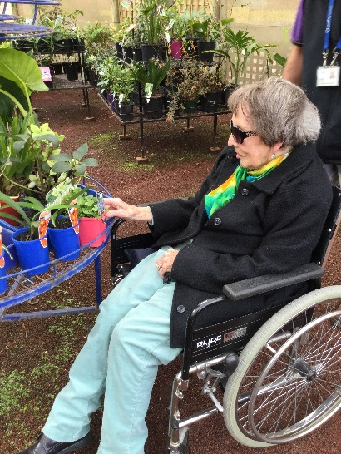
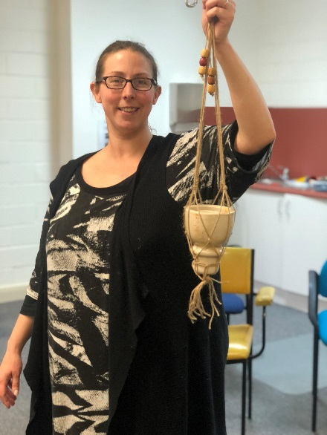
PHOTO PAGES - MEMORIES
Garden Lovers outing

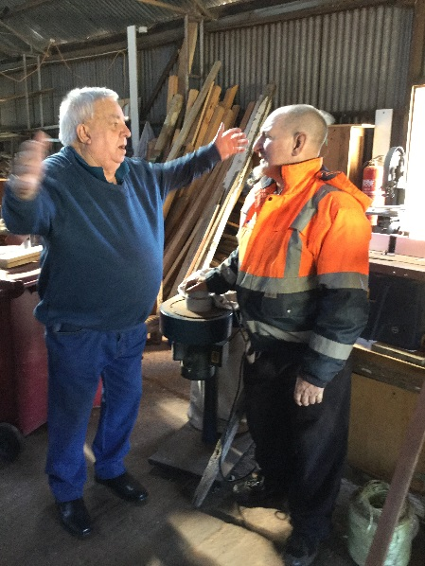
Craftanoon activity

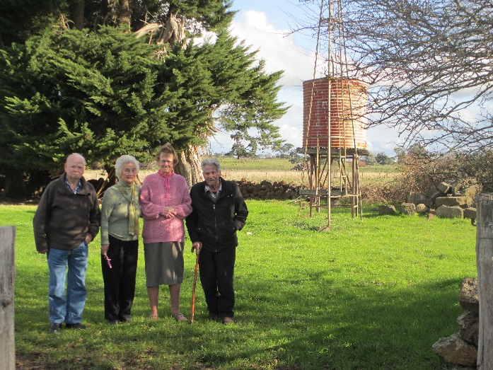

The fish was this BIG
Penshurst group out & about
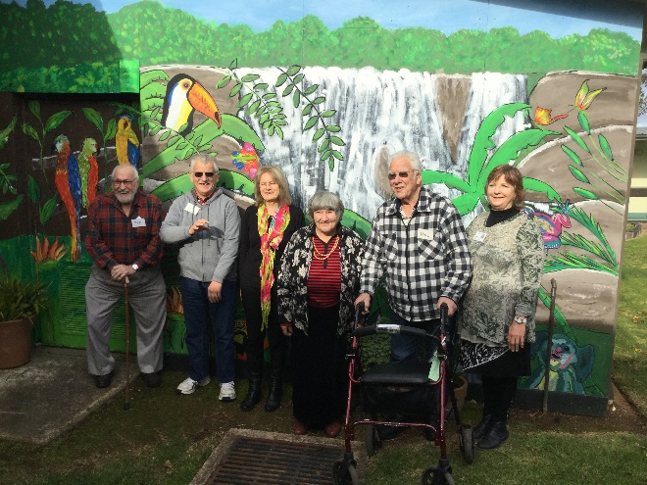
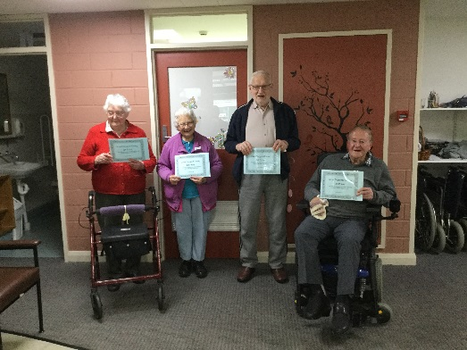
Winners are grinners

A special day: the unveiling of our Mural, a 2 year project led by Michelle Maslen and local artist Lisa Addinsall
Congratulations Members, Michelle & Lisa our Mural looks great and brightens up all dark and gloomy days

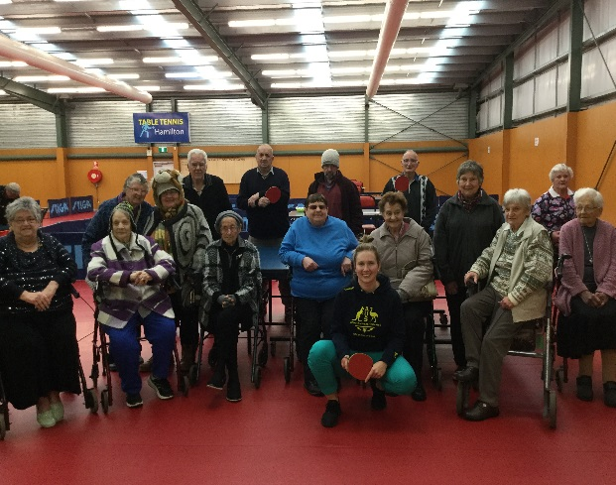
Winsome beating out a tune with Cyprien
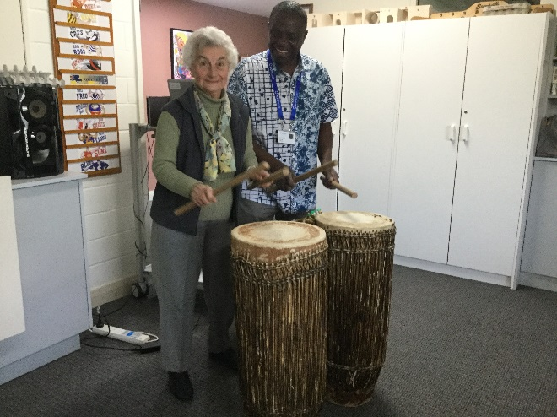

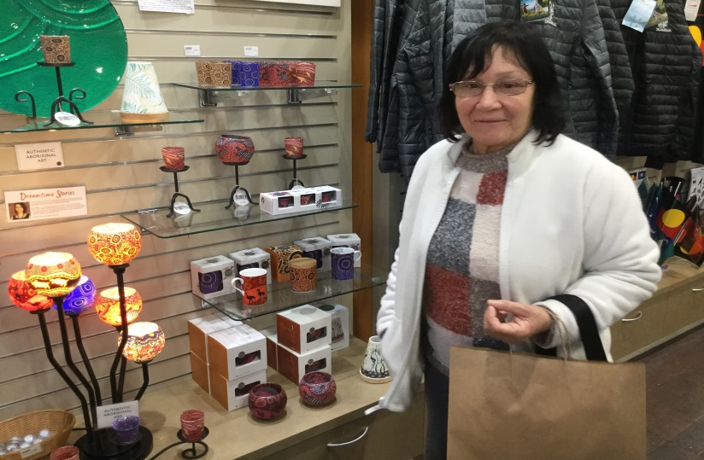
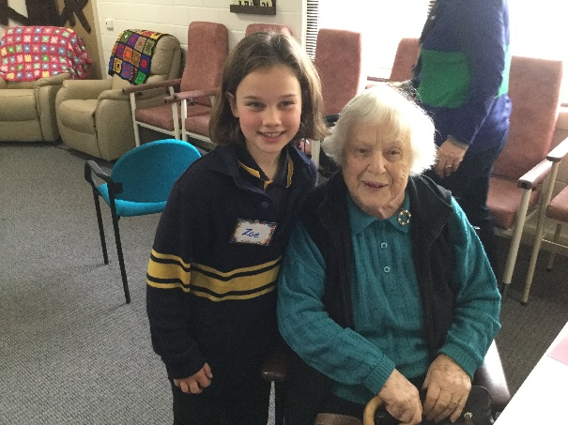
Chris enjoys a shopping outing to Victoria’s Sights and Delights
School visitors from Tarrington and Baimbridge College
Thursday members enjoyed meeting Melissa Tapper at HILAC
Chris loves a shopping outing

