Heart Take Part  Challenging  Classes are for adults who would benefit from exercises to improve heart and lung function, while enjoying the activities in a group setting.  The class consists of a gentle warm up, followed by standing and seated exercises which aim to increase your heart rate and improve movement and general fitness.  Stretches and flexibility exercises are used to cool down.  This class can help with weight management, strength, endurance, flexibility and improve mental health and overall wellbeing.  WE RECOMMEND YOU SEEK YOUR DOCTORS ADVICE BEFORE STARTING ANY EXERCISE.  Participants are encouraged to work at their own pace, exercises can be chair based or conducted with chair support. | Start Staying Strong  Intermediate  Exercises are conducted using light weights and are appropriate for people wanting to increase general strength, making every day activities easier.  The class consists of a gentle warm up followed by strength training with or without weights. Activities to assist with balance are incorporated into this session.  Stretches and flexibility exercises are used to cool down.  This class offers light resistance training for the upper and lower body. People with arthritis, osteoporosis, diabetes, COPD, and cardiac problems may benefit from this class. | Bones Better Best  Easy  This session combines both strength and cardiovascular exercises to improve bone and heart health, and assist with normal everyday activities.  The class consists of a gentle warm up, followed by some seated cardio exercises to gently increase your heart rate. The strength component combines both seated and standing exercises with or without weights.  Stretches and flexibility exercises are used to cool down.  This class can also assist with weight management, strength, endurance, flexibility, improve mental health and overall wellbeing.
Exercises Classes  Available At Frances Hewett  Community Centre  Monday – Friday  For class times, please contact Reception on 555 18450 / 555 18351  Exercise Class  Available at Coleraine  Monday 10:30 am  Cost: $5 per person  For all new participants:  You will be required to complete a registration form prior to commencing the group.  These can be accessed through Reception on 555 18450/ 555 18351 | Programs provided by :  Primary and Preventive Health Division of Western District Health Service  Get fitter, feel better and  have some fun.  Newcomers welcome.  Bring a friend.  Wear comfortable  clothing and shoes.  Bring a water bottle.  For more information contact the Frances Hewett  Community Centre  2 Roberts Street, Hamilton  Phone: 555 18450  Coleraine campus:  555 32000  Pilleau Street, Allied Health Centre Coleraine Hospital | Physical Activity Program  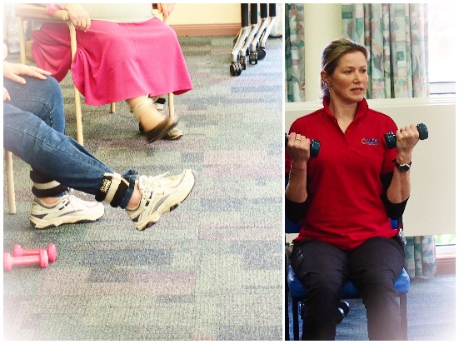  www.wdhs.net
Creating healthier communities
Creating healthier communities

This material has been developed in partnership with consumers.
Reprinted

